**Session report 14/12/2022:**

*LABAUVIE – RAFFAELLI EVA*

*ROB3*

As we got back the Jetson cards, I decided to continue the work I left behinf at the session number 5. I had to do again the first steps. I didn’t managed to do again what I did in the 5th session so I moved to the modelling of the sorting device on Fusion 360.

I’m still going to inspire from this model:

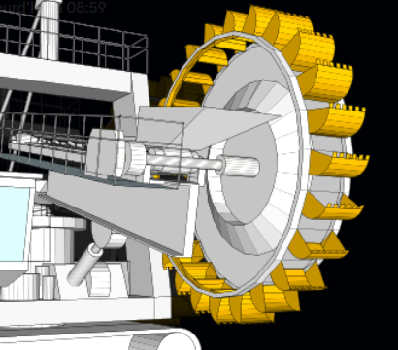

I started by the wheel basic rounded shape.

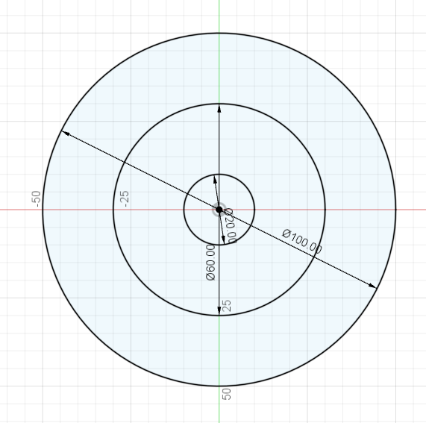

I attempted to make a first wheel with flat edges. (With the “circular network” tool from Fusion).

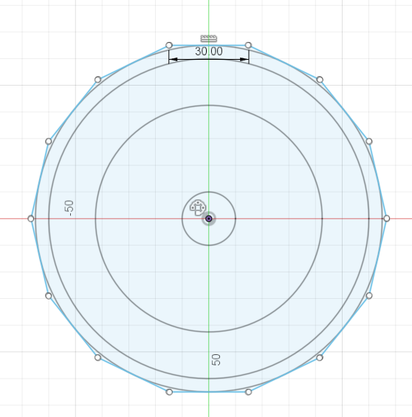

It didn’t work as I wanted, so I reduced the number of edges and made a thin border so I can keep the inside empty.

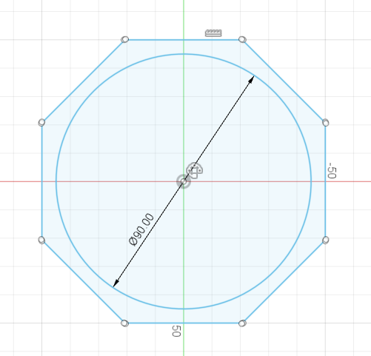

Then I extruded and emptied each faces (so the sand falls through).

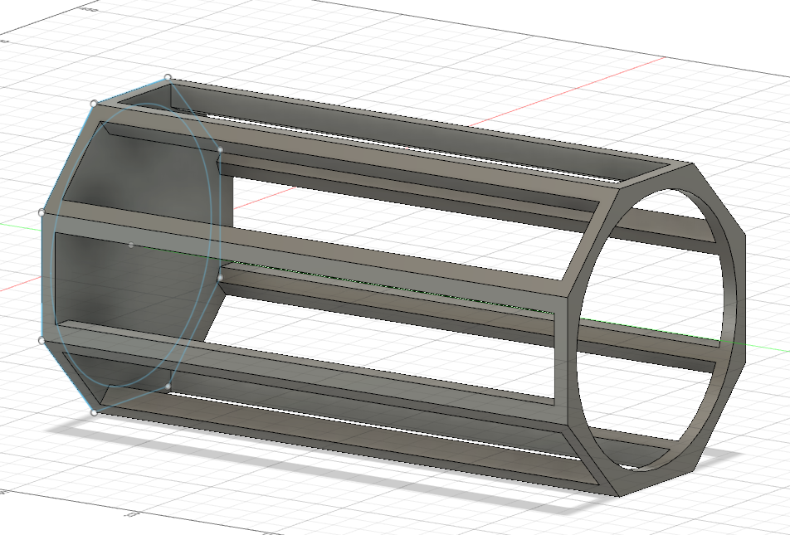

I added an axis and reinforced the base

